**Revit Voxelization Tool Guide to Authors**

4/2/2025

目录

1 Introduction 1

2 Installation 1

3 Running the tool 2

4 Model Voxelization 3

5 Run validation test 8

6 Run path planning 12

# Introduction

This tool is developed for compressing MEP model created by Revit. Currently the tool support Revit 2016, 2018,2020,2021,2022,2023, and 2025. The user can open the Compiled folder to and choose a version based on your Revit version. If the tool cannot run, we strongly recommend the users to compile the source code again and run the compiled tool.

# Installation

The tool is run by the Revit Addin Manager, which is an add-in for Revit. If you have not install the Addin Manager, please quit the Revit application, copy all the files in the AddinManager to the folder C:\ProgramData\Autodesk\Revit\Addins\[your Revit version]\, and restart the Revit application. Then you can find it appears in the Add-Ins Tabs. As is shown in Fig. 1.

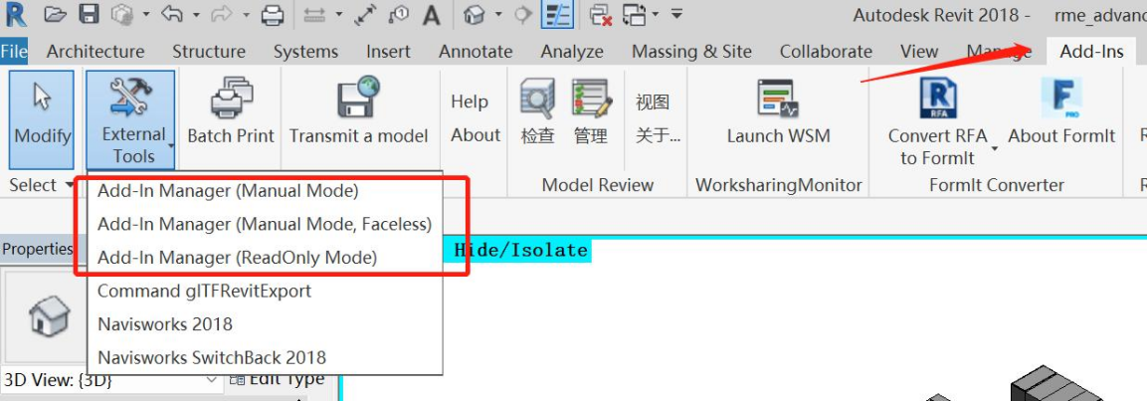

Fig. 1 Addin Manager installed in Revit

Click the “Add-In Manager（Manual Mode）” , Click “Load”, choose the dll of your Revit version in the Complied folder, as is shown in Fig.2



Fig. 2 Load the tool in Addin-Manager

If load failed, you have to rebuild the source code. The process is shown in Fig.3.



Fig. 3 Rebuild the source code

# Running the tool

The method of running the tool is shown in Fig. 4.

Fig. 4 Running the tool

# Model Voxelization

To voxelize a model, the following processes should be done:

1st. Set a proper voxels size, the click the “Generate(Model)” to voxel current model, as is shown in Fig. 5.

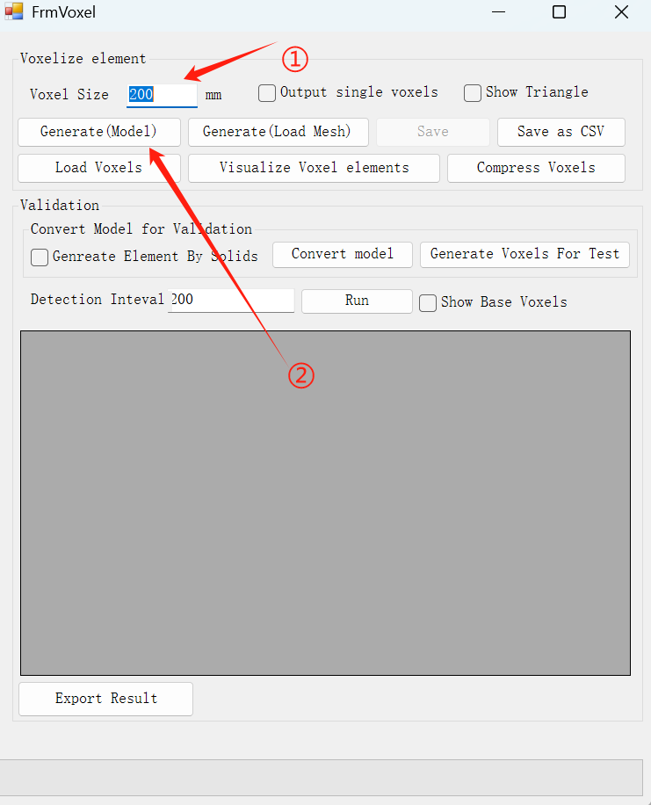

Fig. 5 Step 1

2nd When the model meshes are obtained, a dialogue will appear. By Click “Yes”, the obtained meshes can be saved in your computer, by click “No” to skip saving the meshes. As is shown in Fig. 6.

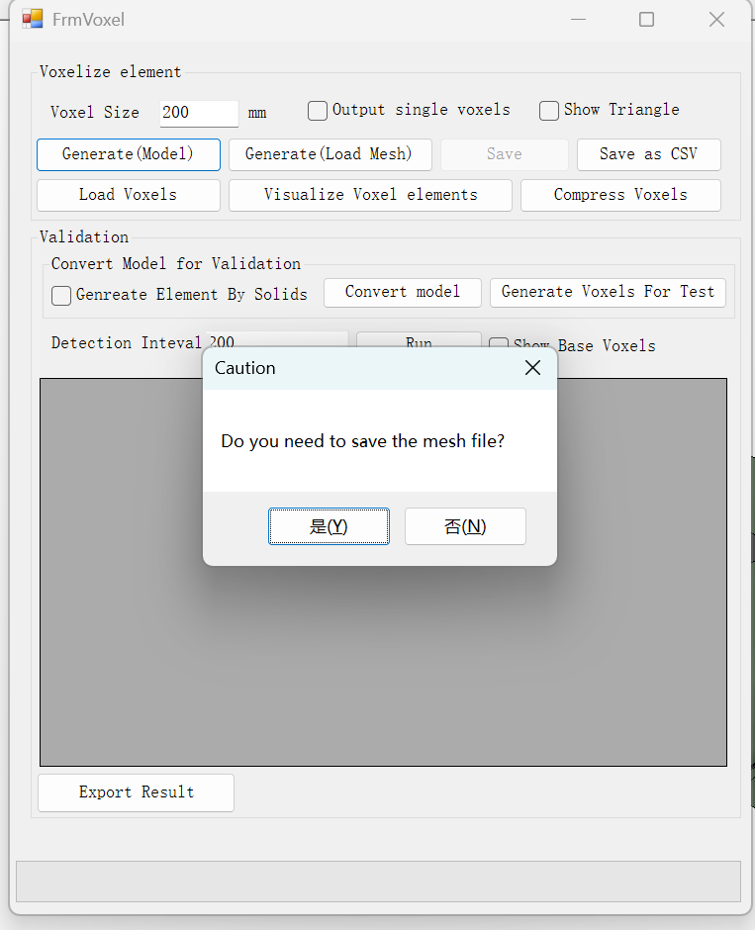

Fig. 6 Triangle mesh obtaining

3nd Then another dialogue appears. Click “Yes” to begin voxelization, as is shown inFig. 7.

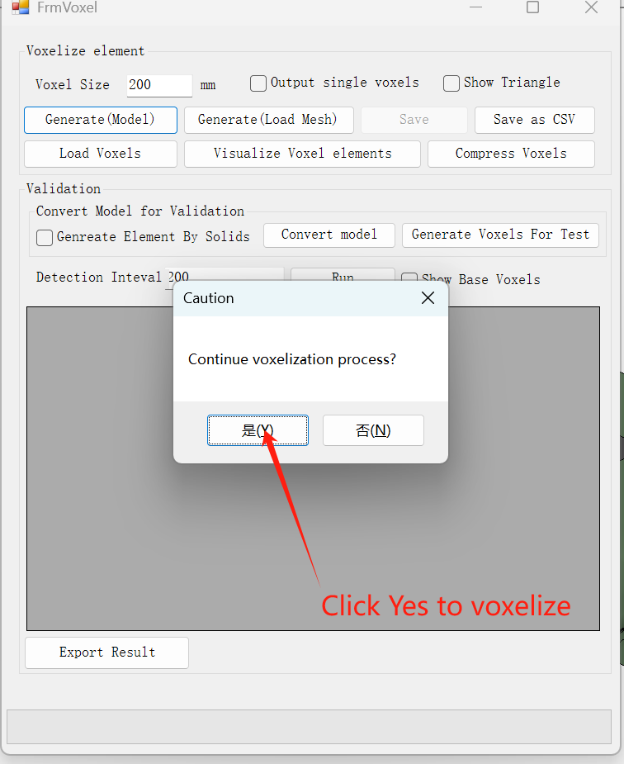

Fig. 7 Step 3

4th Wait until the voxelization process finishes, as is shown in Fig. 8.

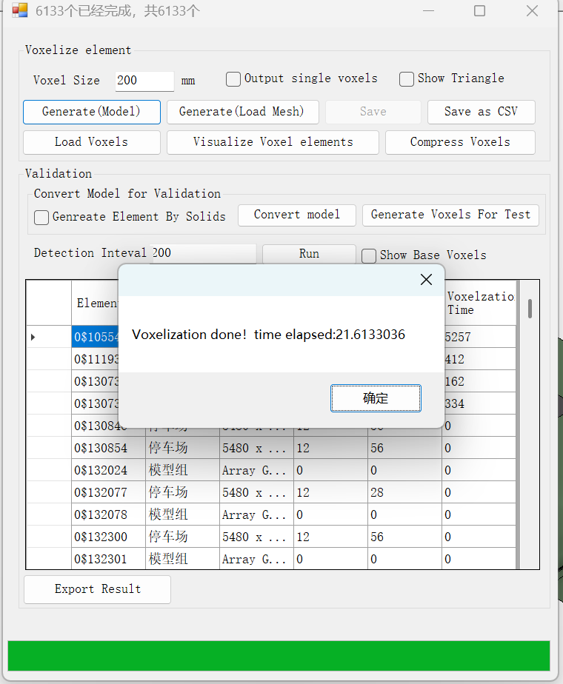

Fig. 8. Step 4

5th (Optional) If the user hope to save the voxel file, click “Save” to save the generated voxels, as is shown in Fig. 9.

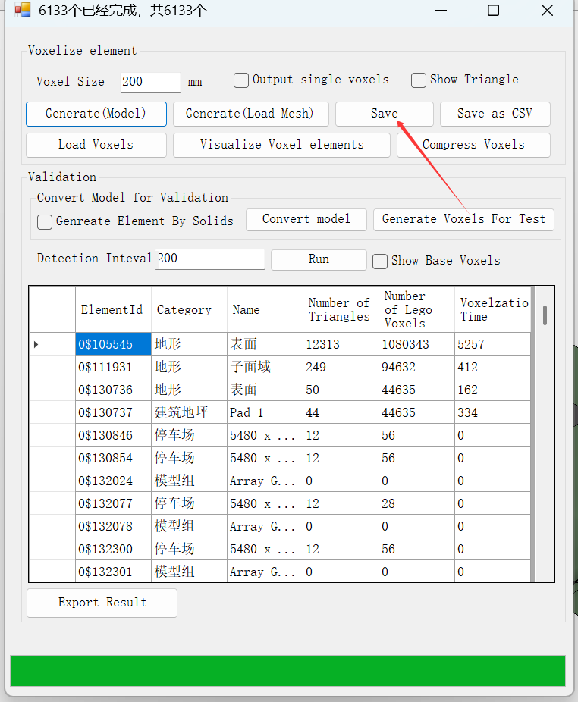

Fig. 9 Saving the generated voxels

6th (Optional) If the user hopes to save the number of voxels and elapsed time per element, click “Export Result” to save them as a CSV files. voxels, as is shown in Fig. 10.

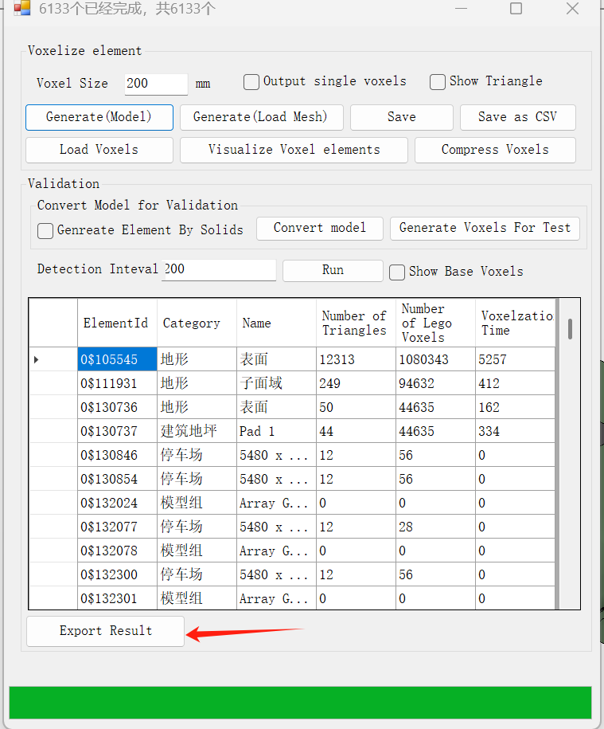

Fig. 10 Export voxel data by elements

7th (Optional) If the user hopes to visualize the voxels of the model, click “Visualize voxelized elmenets”, as is shown in Fig. 11. Please be advised that this process consumes a large amount of time and memory, so it is not recommended to run this function on large-scale models.



Fig. 11 Visualizing the voxels

# Run validation test（Not finished yet）

1st. Click “Convert model”, the elements containing solids in the model will be replaced with direct shapes whose categories are “Generic Models”. The direct shapes will be gathered in a group, and the original elements will be hided. Meanwhile the current Revit document will be saved as a new one for the test. If current model has been previously converted, there is no need to convert again.

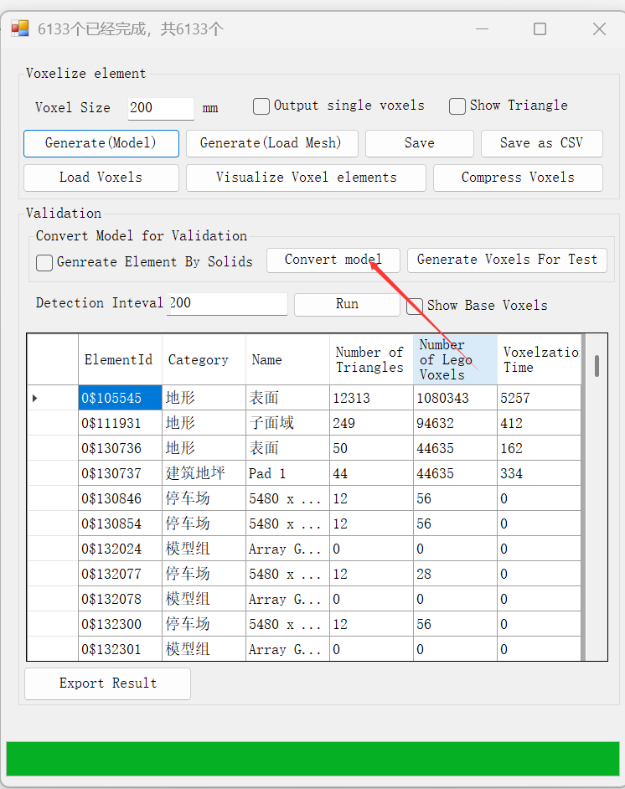

Fig. 12 Model conversion for validation test.

2st. Click “Generate voxels for test” to generate test voxels, as is shown in Fig. 13.

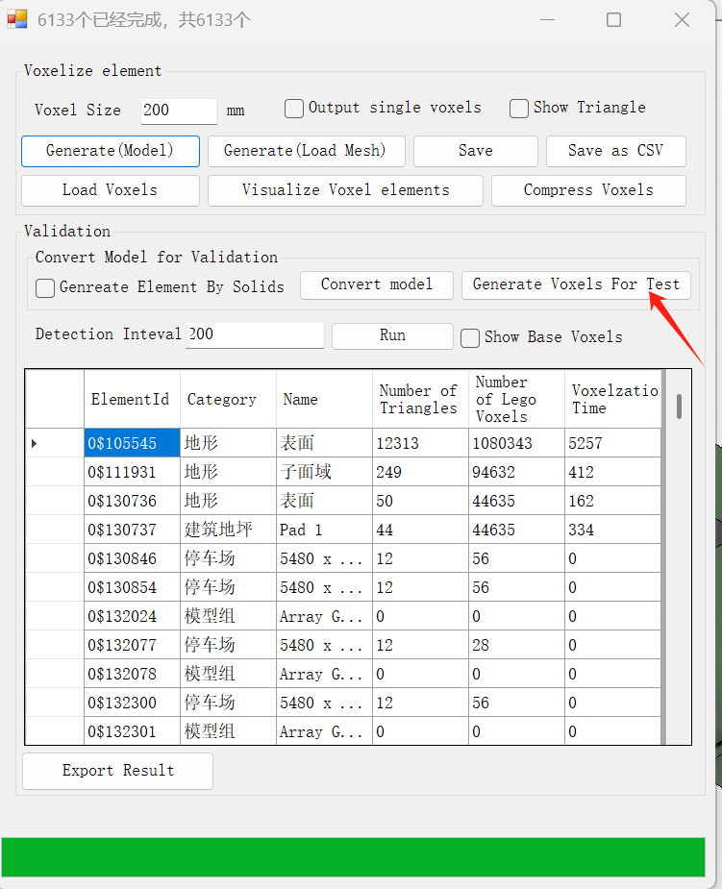

Fig. 13 Test voxel generation

3rd (Optional). Choose a proper height for base voxels, as is shown in Fig. 14.

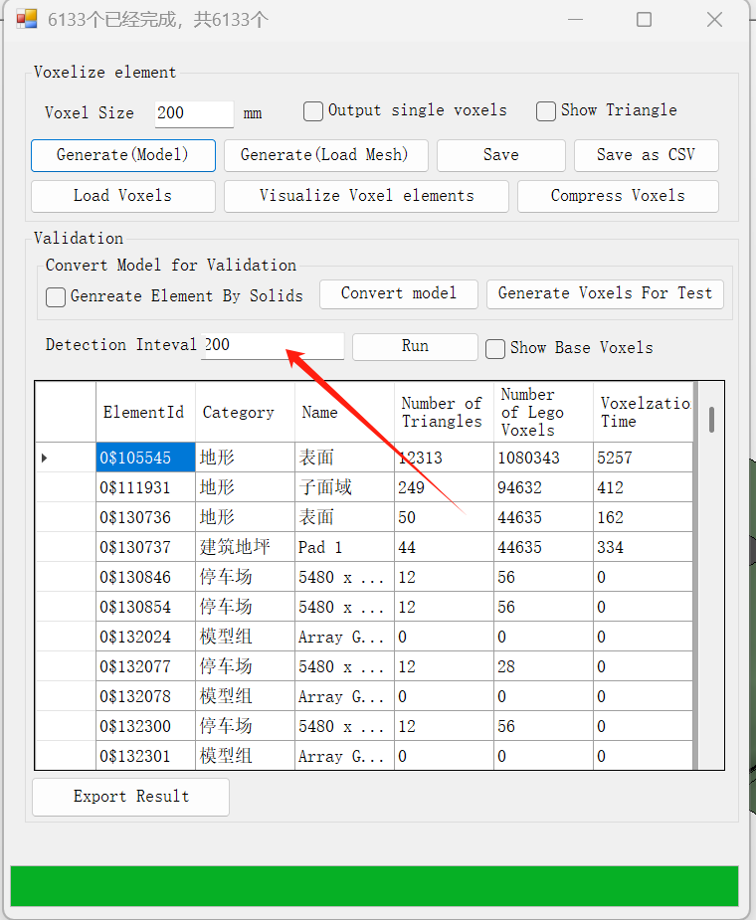

Fig. 14 Set a height for the base voxel

4th.Click “Run” to generate the base voxels, as is shown in Fig. 15. Please note that this process is very slow, for a larger model, it may take several days for this test.

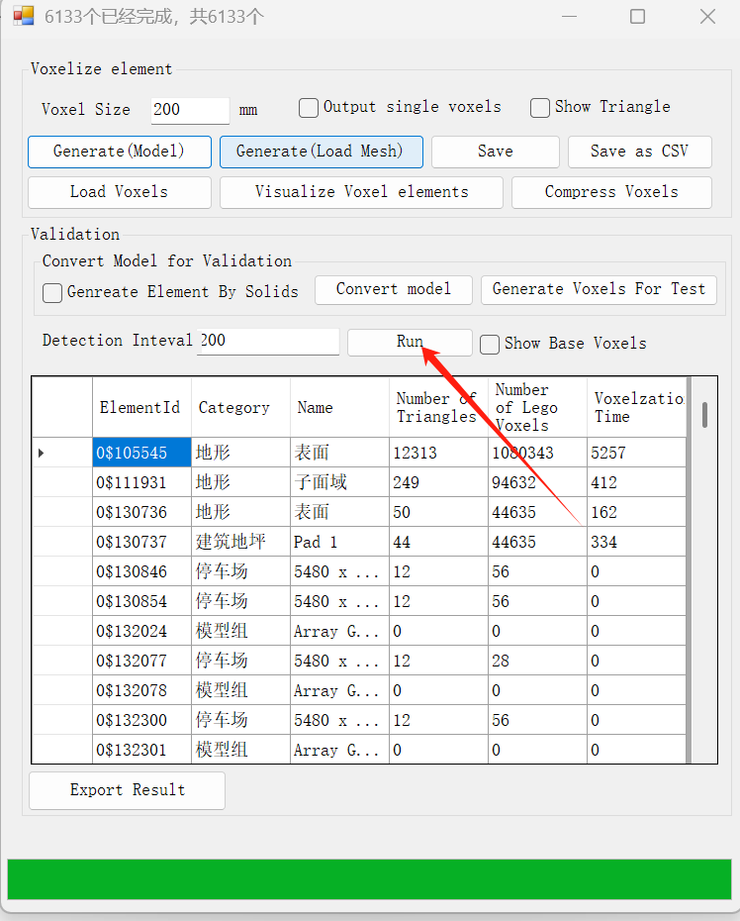

Fig. 15 Base voxel generation

5th When the test is done, the result will shows in the data grid view in the right of the UI, Users can click the “Export Result” button to output the results as well as the model information aforementioned as csv files for further research.

6th (Optional) If the user want to see the redundant or missing voxels of a specific element, click the rows of the corresponding element in the data grid view above, then the missing and redundant voxels (if any) are visualized in model, as is shown in Fig. 16.



Fig. 16 Result visualization

# Run path planning

1st Place 2 RPC instances in the model resembling the start and target location. As shown in Fig. 17.

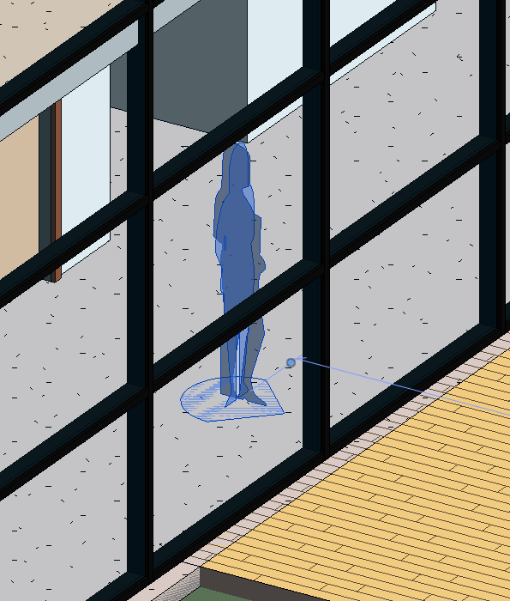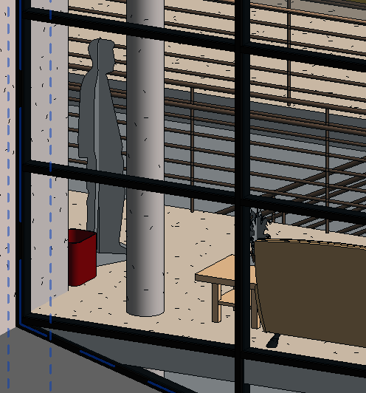

Fig. 17 Set start and target location

2nd. Generate and save the voxels, as shown in Fig. 18. The extension of the file is.vox

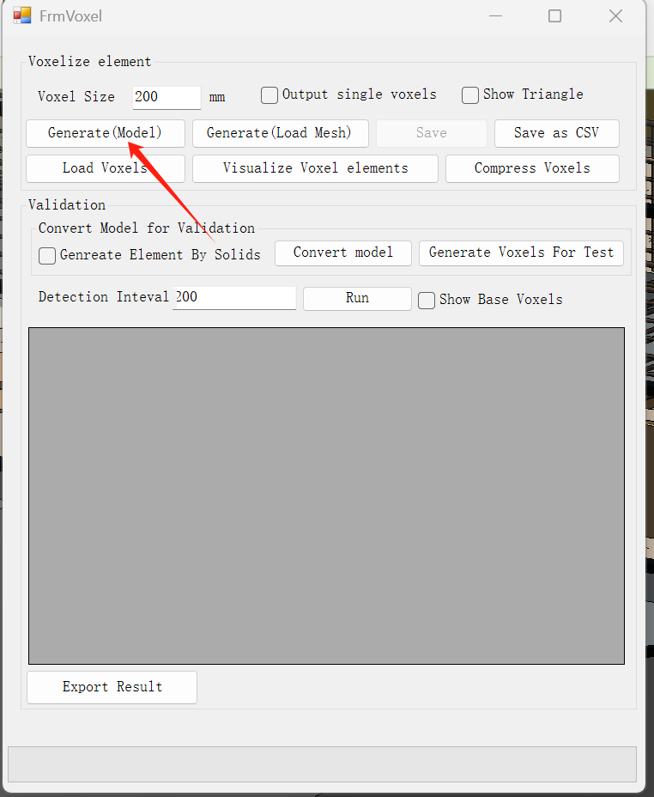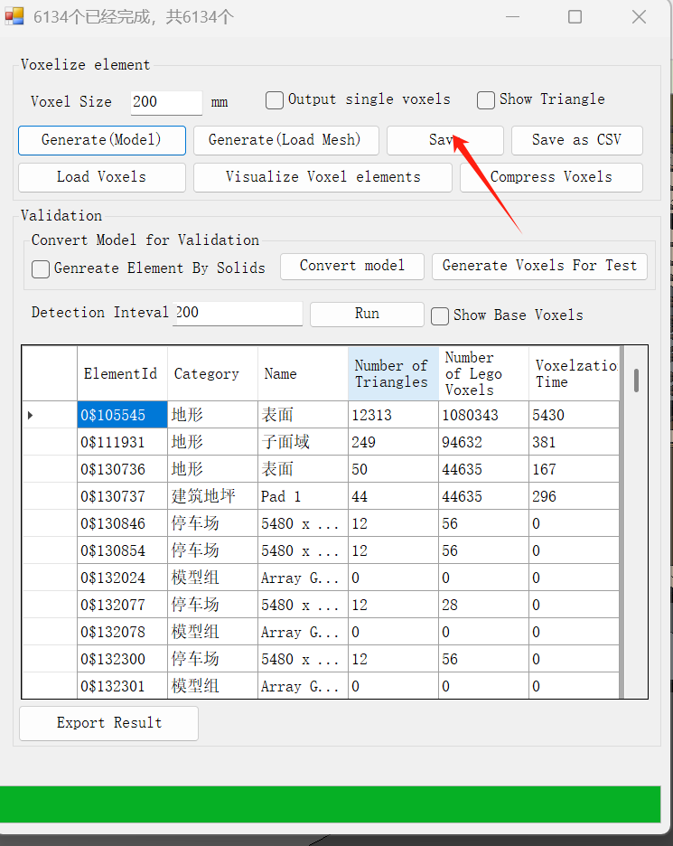

Fig. 18 Set start and target location

3rd Click the “Cmpress Voxels” , a form will pop up. Then click the “Compress Voxels” button，and load The vox file in the previous step. As shown in Fig. 19.

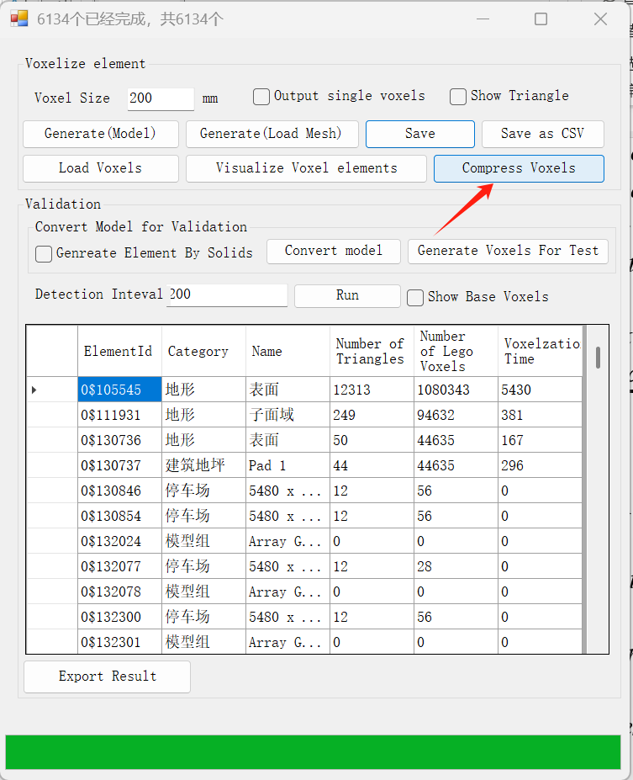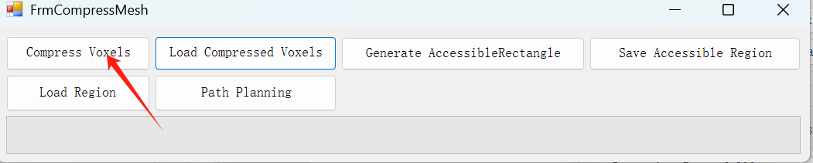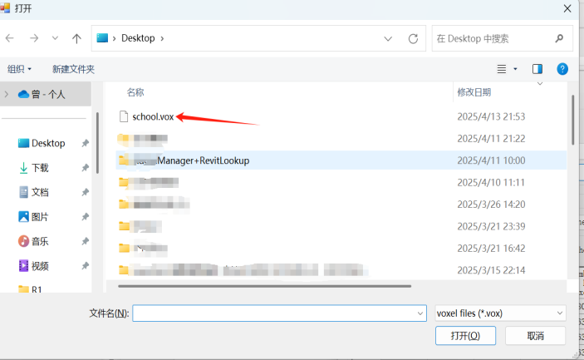

Fig. 19 Compress voxel for path planning

4th Then nother dialogue will appear. Set a proper filename and save the compressed voxel file, whose extension is “.cvox”. As shown in Fig. 20.

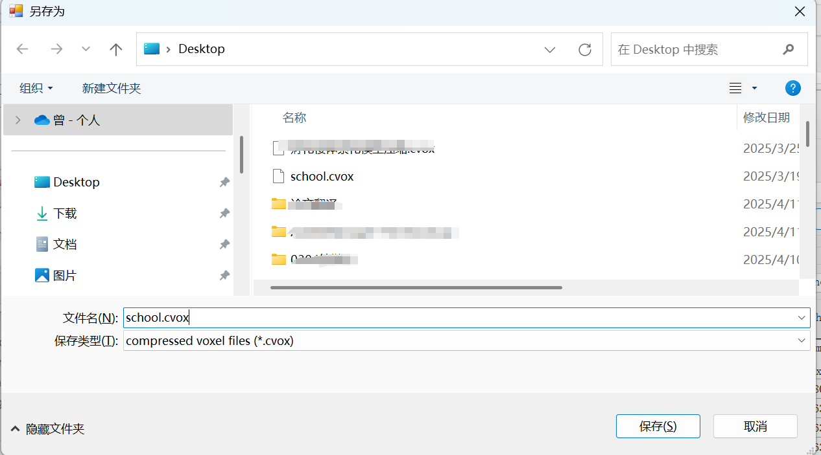

Fig. 20 Saving the compressed voxel file

5th Wait until the compression is done. As shown in Fig. 21

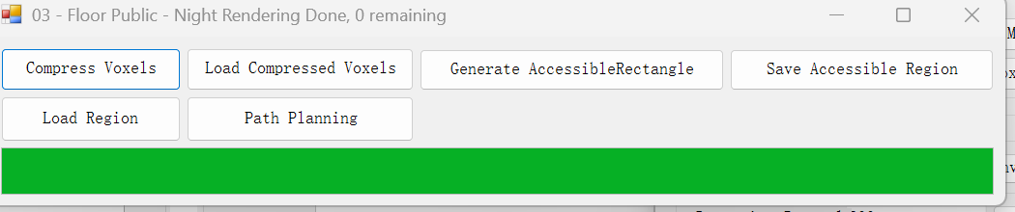

Fig. 21 Compression done

6th Load the compressed voxels by clicking the “Load Compressed Voxels” button. As shown in Fig. 22.

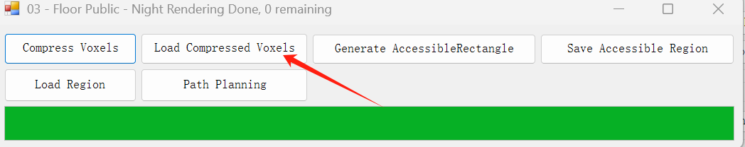

Fig. 22 Loading compressed voxels

7th. Click the “Generate AccessibleRectangles” button to generate indoor navigation map. As shown in Fig. 23.

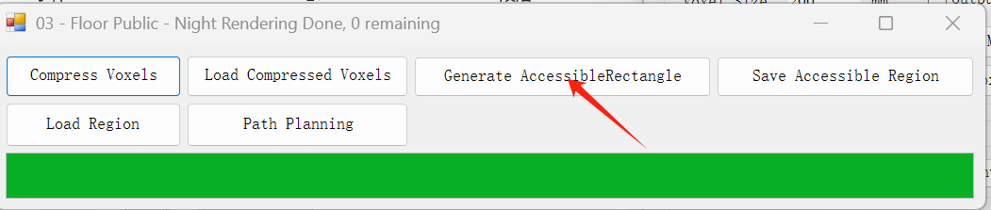

Fig. 23. Generate Accessible Rectangles

8th The form shown in Fig. 24 appears, click ”No” not visualize the result and continue.

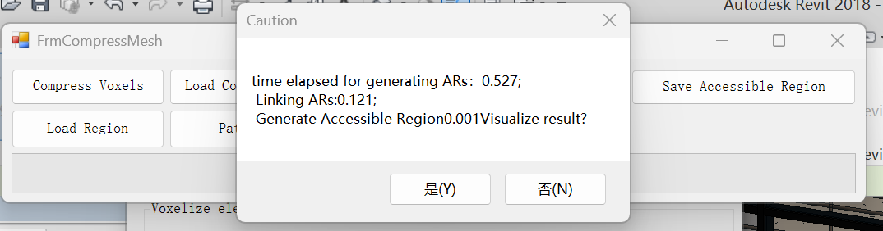

Fig. 24 Generate accessible region complete

9th Save the generated path-planning environment as an accessibleRng files. As shown in Fig. 25.

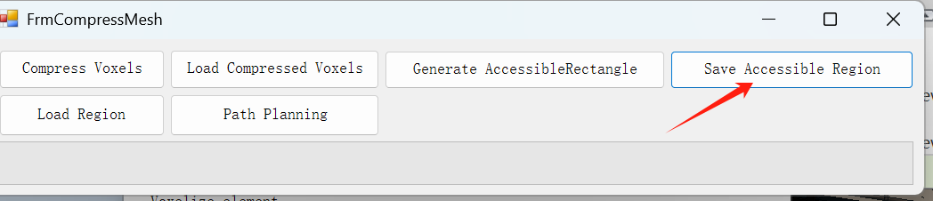

Fig. 25 Save accessible region files

10th Click the “Load Region”to load the accessible region. As shown in Fig. 26

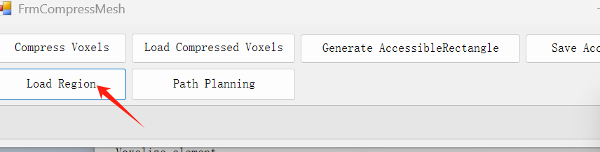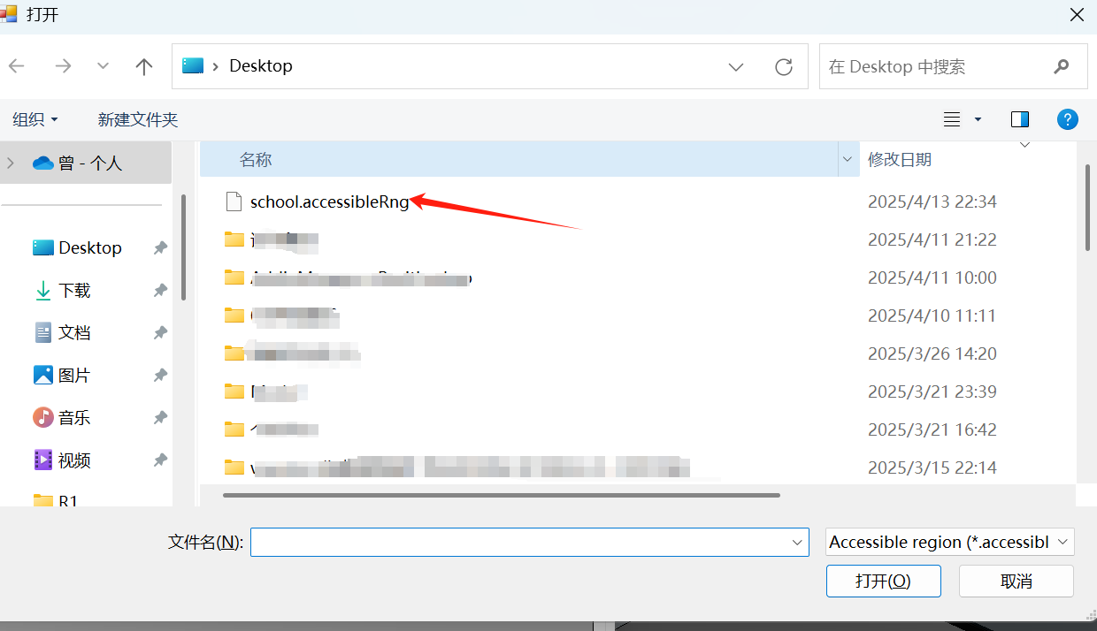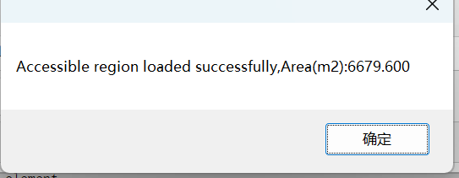

Fig. 26 Load Region

11th Click “Path planning”, then choose the RPC instances as the start and target location, a model line string will generate to show the path. As shown in Fig. 27.

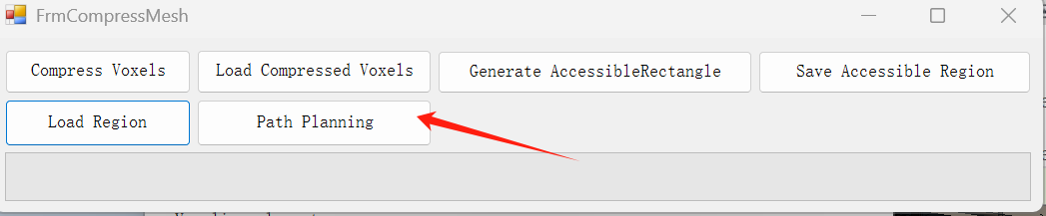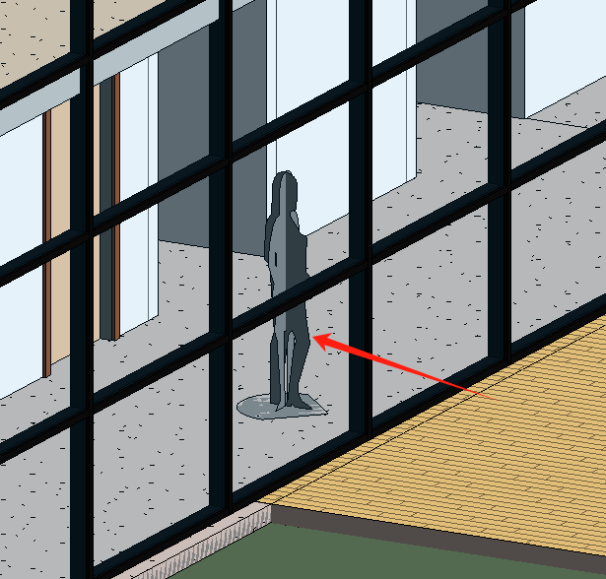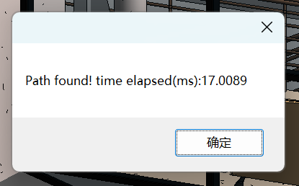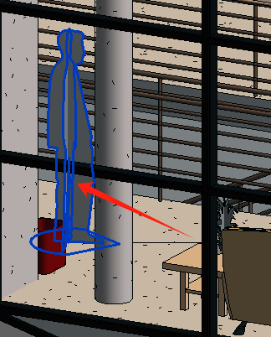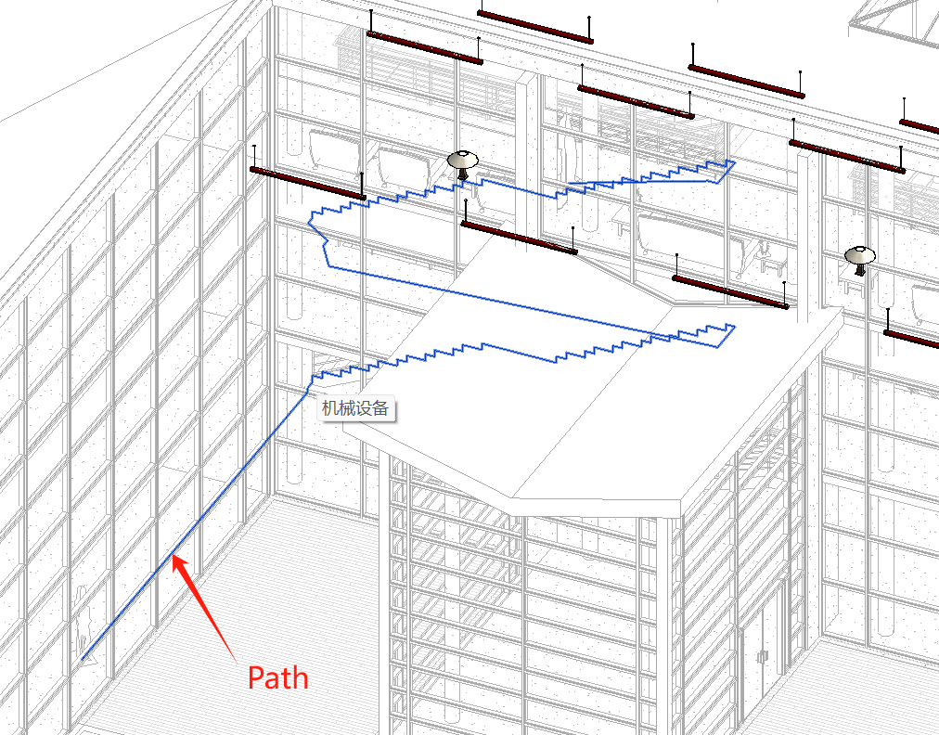

Fig. 27 Path planning